

**Lawrence Nadar**

1. **Are the HTML tags and elements the same thing?**

* No, HTML tags and elements are both the different things but they are relatable to each other
* Tags have opening tag and closing tag and content lies in between the tags. (Opening Tag <> and Closing Tag </>)
* Element defines the type of content written inside the tag. (<h1>I am Heading</h1>)
* These are the main component to start creating a web structure.
* Element defines what type of content is written.

1. **What are tags and attributes in HTML?**

* Tags are use to enclose the keywords like P, h1 in an angled bracket **(<p></p>, <h1></h1> etc.)**
* **<Opening Tag> Content </Closing Tag>**
* Some Tags are called self-closing tag which does not required closing tag **(Ex. <img/>, <br/>, <input/>)**
* Attributes adds more detailed meaning or additional information or provide more context to the element and gives characteristics to a single element which directly influence the behaviour, appearance or linking destination.
* Example of attributes.
  + <img src= ” image file path or image link”/>
  + <a href= ” google.com”>Google</a>

Here href, src, name, value etc. are known as attributes.

**3.What are void Elements in HTML?**

* **Void elements are known as the self-closing tags because it does not require the closing tag.**
* **For Ex. <img/>,** **<br/>, <input/> this void element only contains attributes not a content.**

**4.What are HTML Entities?**

* **In HTML some characters are reserved for different symbols like**
* **copyright ©️ = &copy, Greater than > = &gt, less than < = &lt, etc**

**5. What are different types of lists in HTML?**

* **There is main 3 types of lists in HTML Orderd lists, Unorderd list and Definition lists**

**1)Ordered List:**

**<ol>**

**<li></li>**

**<li></li>**

**<li></li>**

**</ol>**

**2) Unordered List:**

**<ul>**

**<li></li>**

**<li></li>**

**<li></li>**

**</ul>**

**3) Definition List:**

**<dl>**

**<dt></dt>**

**<dd></dd>**

**</dl>**

* **Order list defines list in a order using Numbers, Roman numbers, Capital letters, Small letters**
* **Unorder list defines list in a non-order format Circle, square, Dark circle(default)**

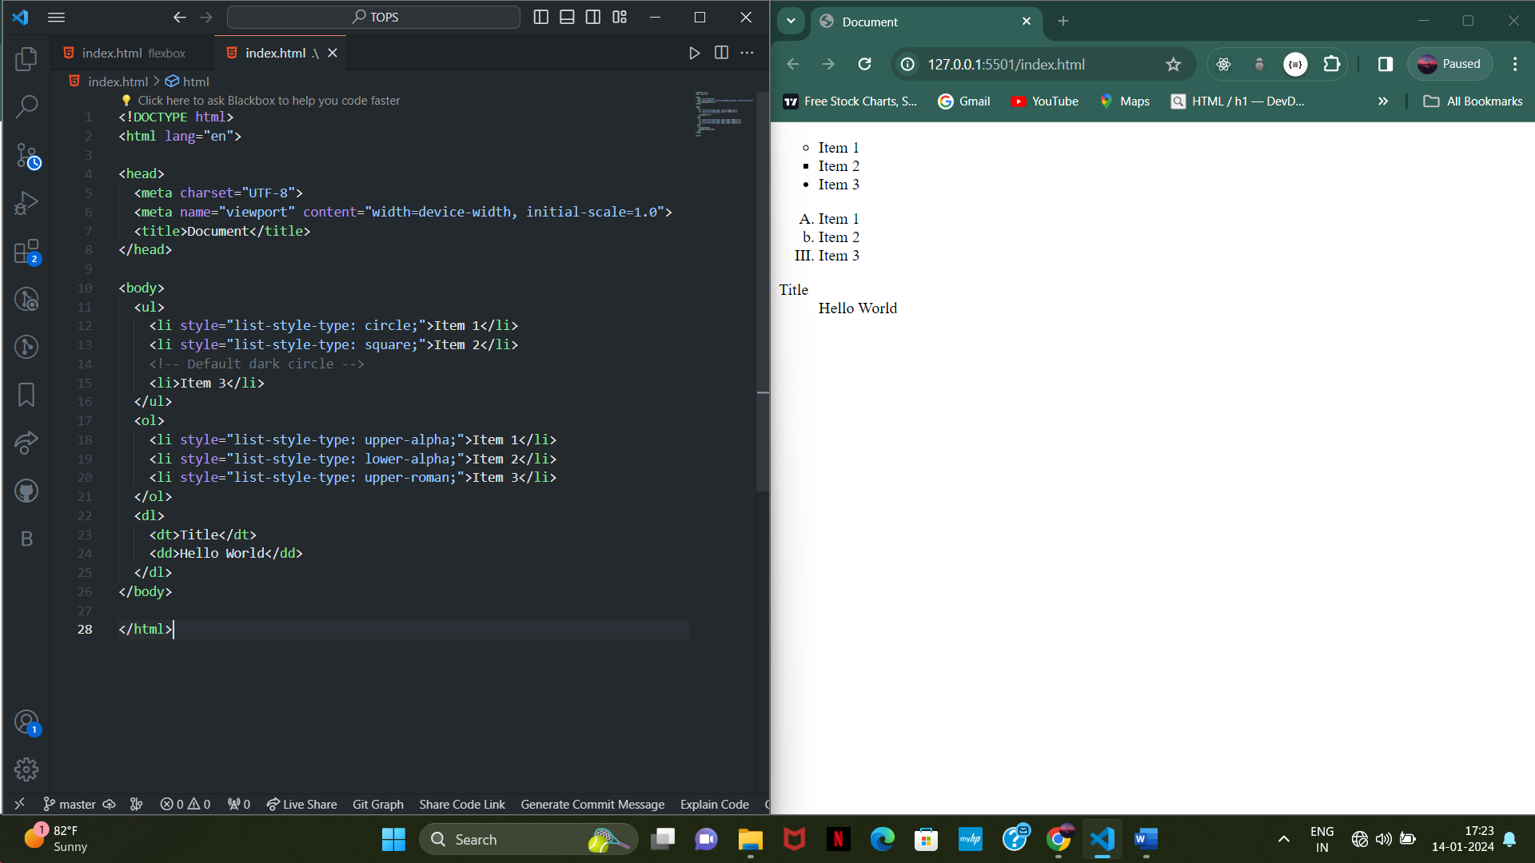

**6. What is the “class” attribute in HTML?**

* **Class attribute is used to give same properties to different elements at the same time. It can be used as many times as we want.**

**7. What is the difference between the “id” attribute and the “class” attribute of HTML elements?**

* **Difference between ID and Class is ID can only be used one time in a page and Class can be used many times as we want.**

**8. What are various formatting tags in HTML ?**

* **<b/>**
* **<strong></strong>**
* **<i></i>**
* **<em></em>**
* **<del></del>**
* **<sub></sub>**
* **<sup></sup>**

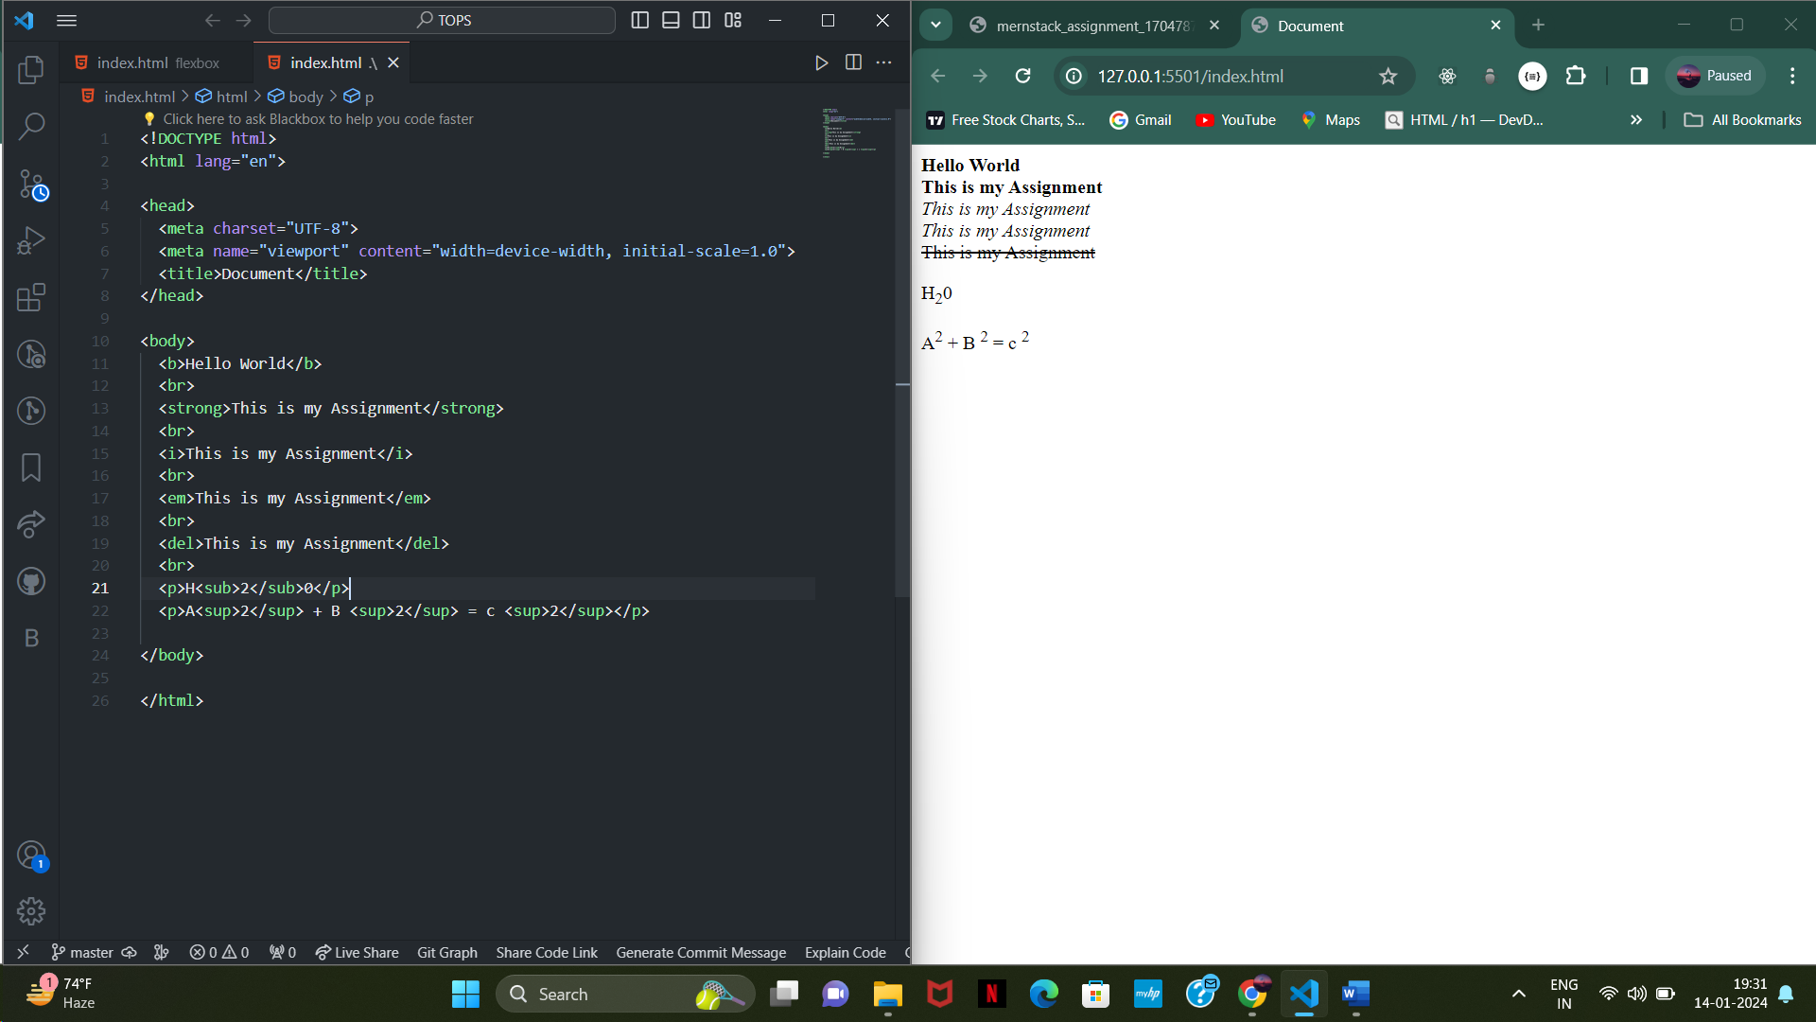

1. **How is Cell Padding different from Cell Spacing?**

* **Cellpadding defines space inside the cell or around the content**
* **Cell spacing defines space between other cells**

1. **How can we club two or more rows or columns into a single row or column in an HTML**

**table?**

* **To merge the columns we require colspan and to merge the rows we need to merge the rowspan.**
* **Colspan:**
* 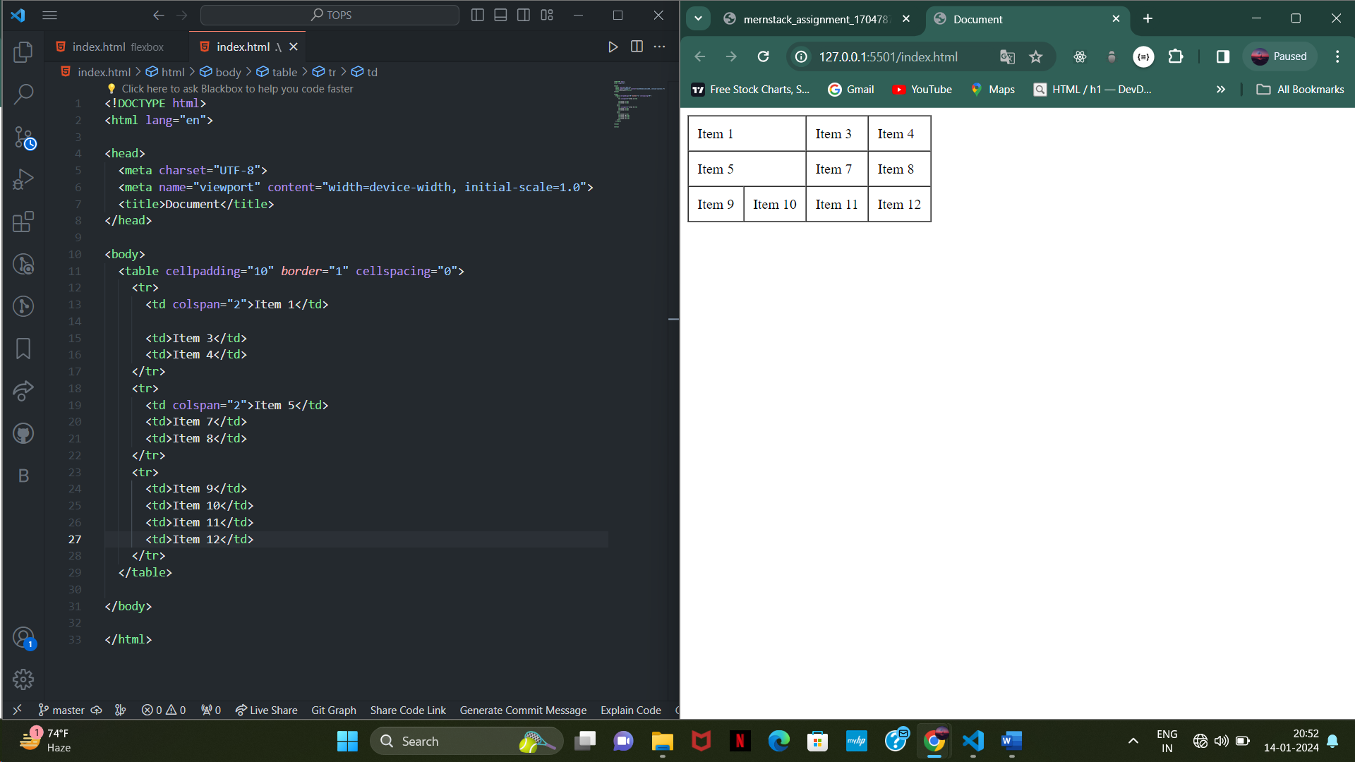
* **Rowspan:**
* 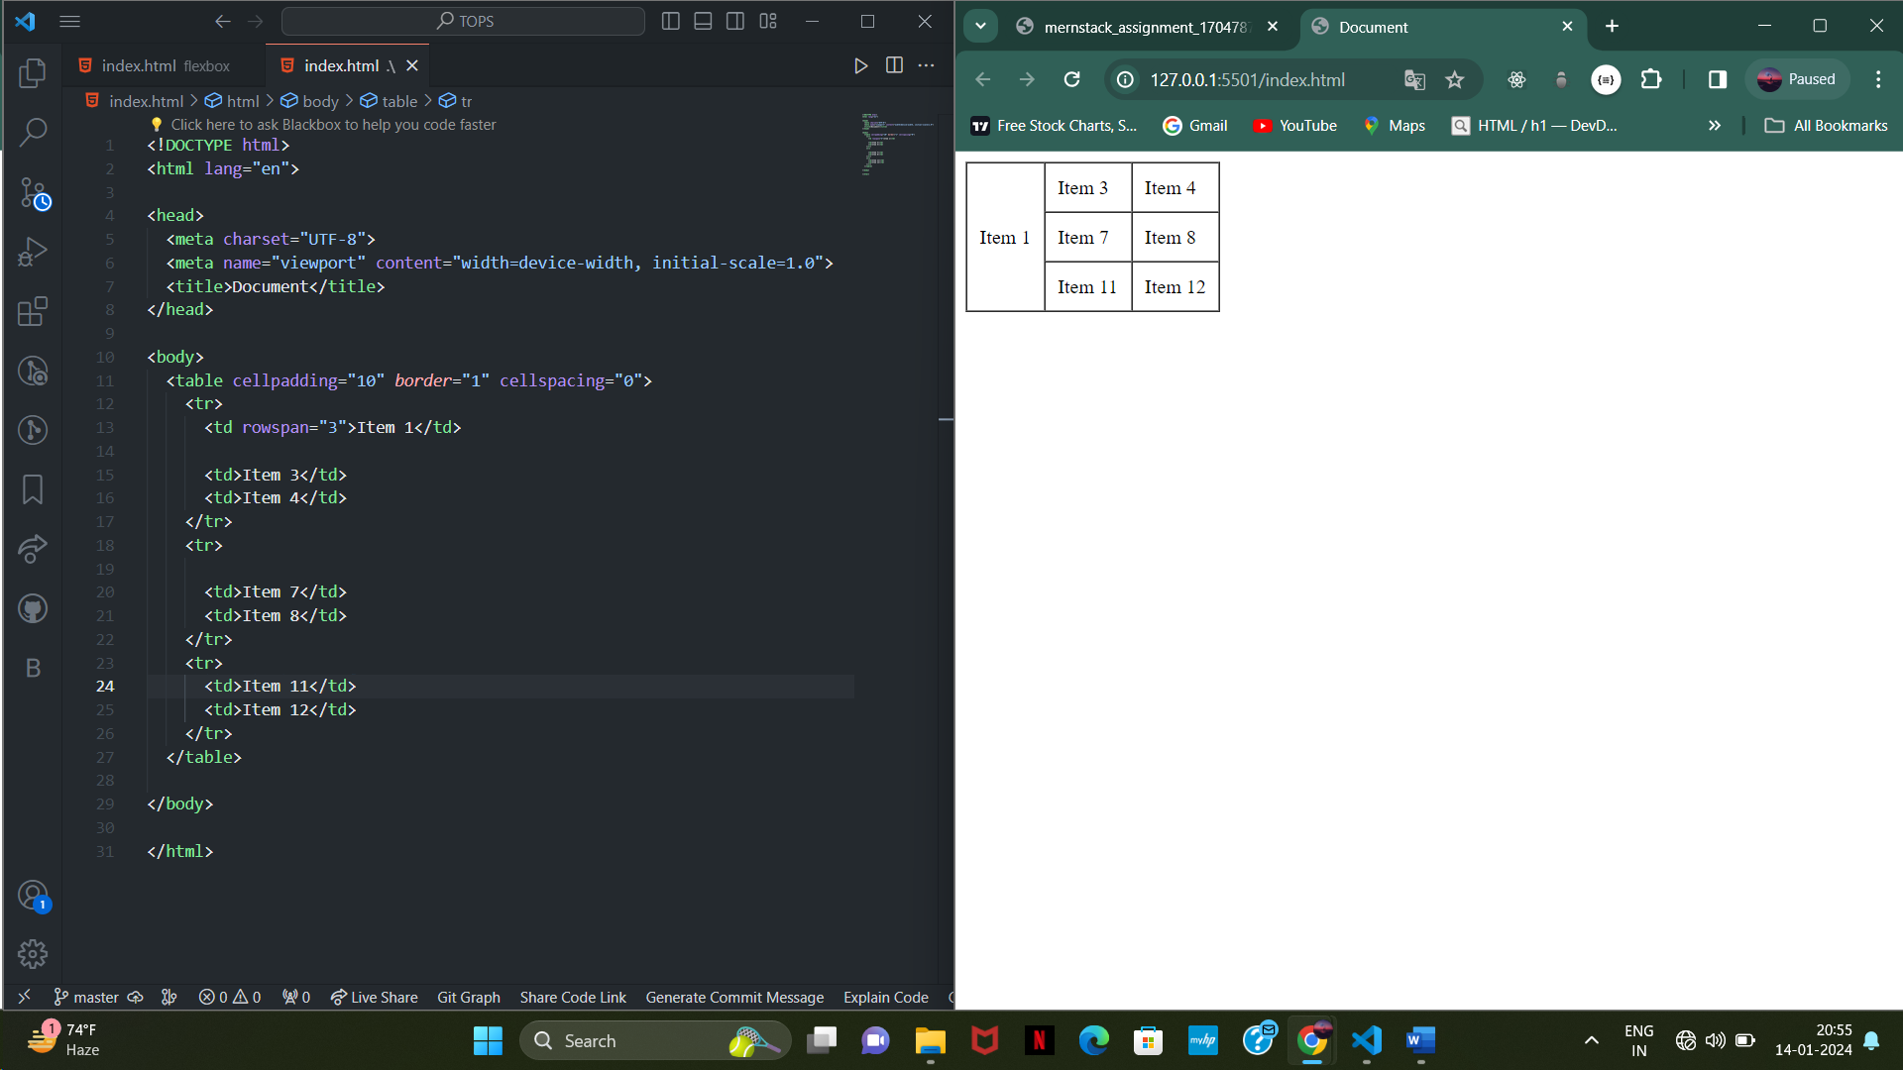

1. **What is the difference between a block-level element and an inline element?**

* **Block level elements occupy full width of the display and starts on a new line.**

**Margin and Padding applies on every side**

**Example: <p>, <h1> to <h6>, <ul>.**

* **Inline elements take as much width as needed and does not start on a new line.**

**Margin and Padding applies only on right and left side.**

**Example: <span>, <img>**

1. **How to create a Hyperlink in HTML?**

* **Hyperlink can be created using anchor tag.**

**Example: <a href=”Google.com”>Google</a>**

1. **What is the use of an iframe tag?**

* **Iframe tag is also known as inline frame and it is used to embed other HTML document codes or contents like videos, map , webpage. Within specific area on the web page.**

**It creates a frame inside the website to display external content.**

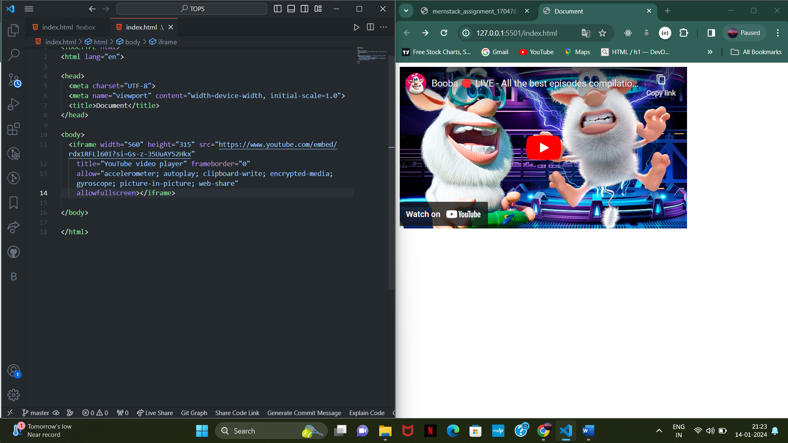

1. **• What is the use of a span tag? Explain with example?**

**Span tag in HTML is use to apply styles to a specific section of a text.**

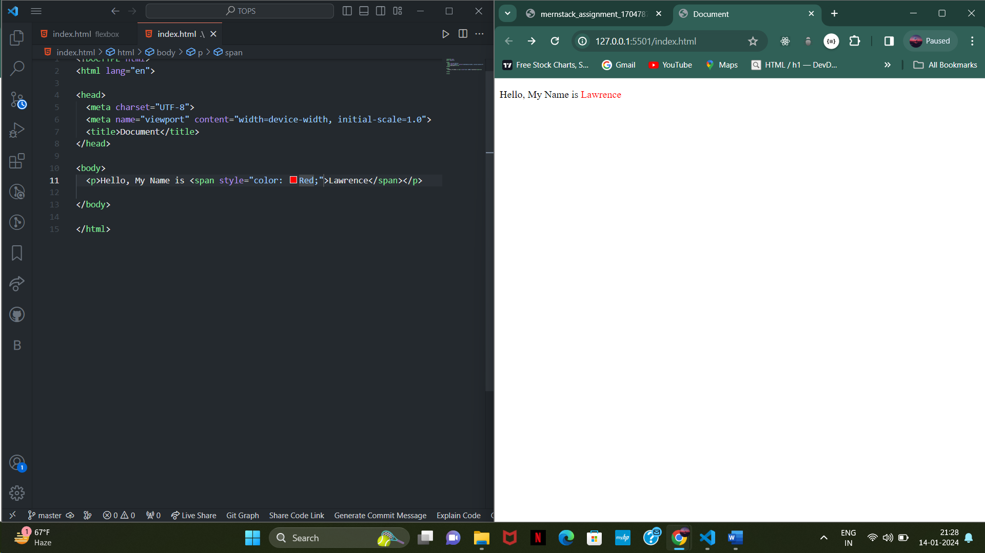

**Here I used span tag just to modify style of Lawerence not a whole Paragraph content.**

**This allows flexible styling of a content in a page.**

**Span is a inline element which takes as much space as needed.**

1. **How to insert a picture into a background image of a web page?**

**To insert a background we need to use Background-image property to insert image in a background.**

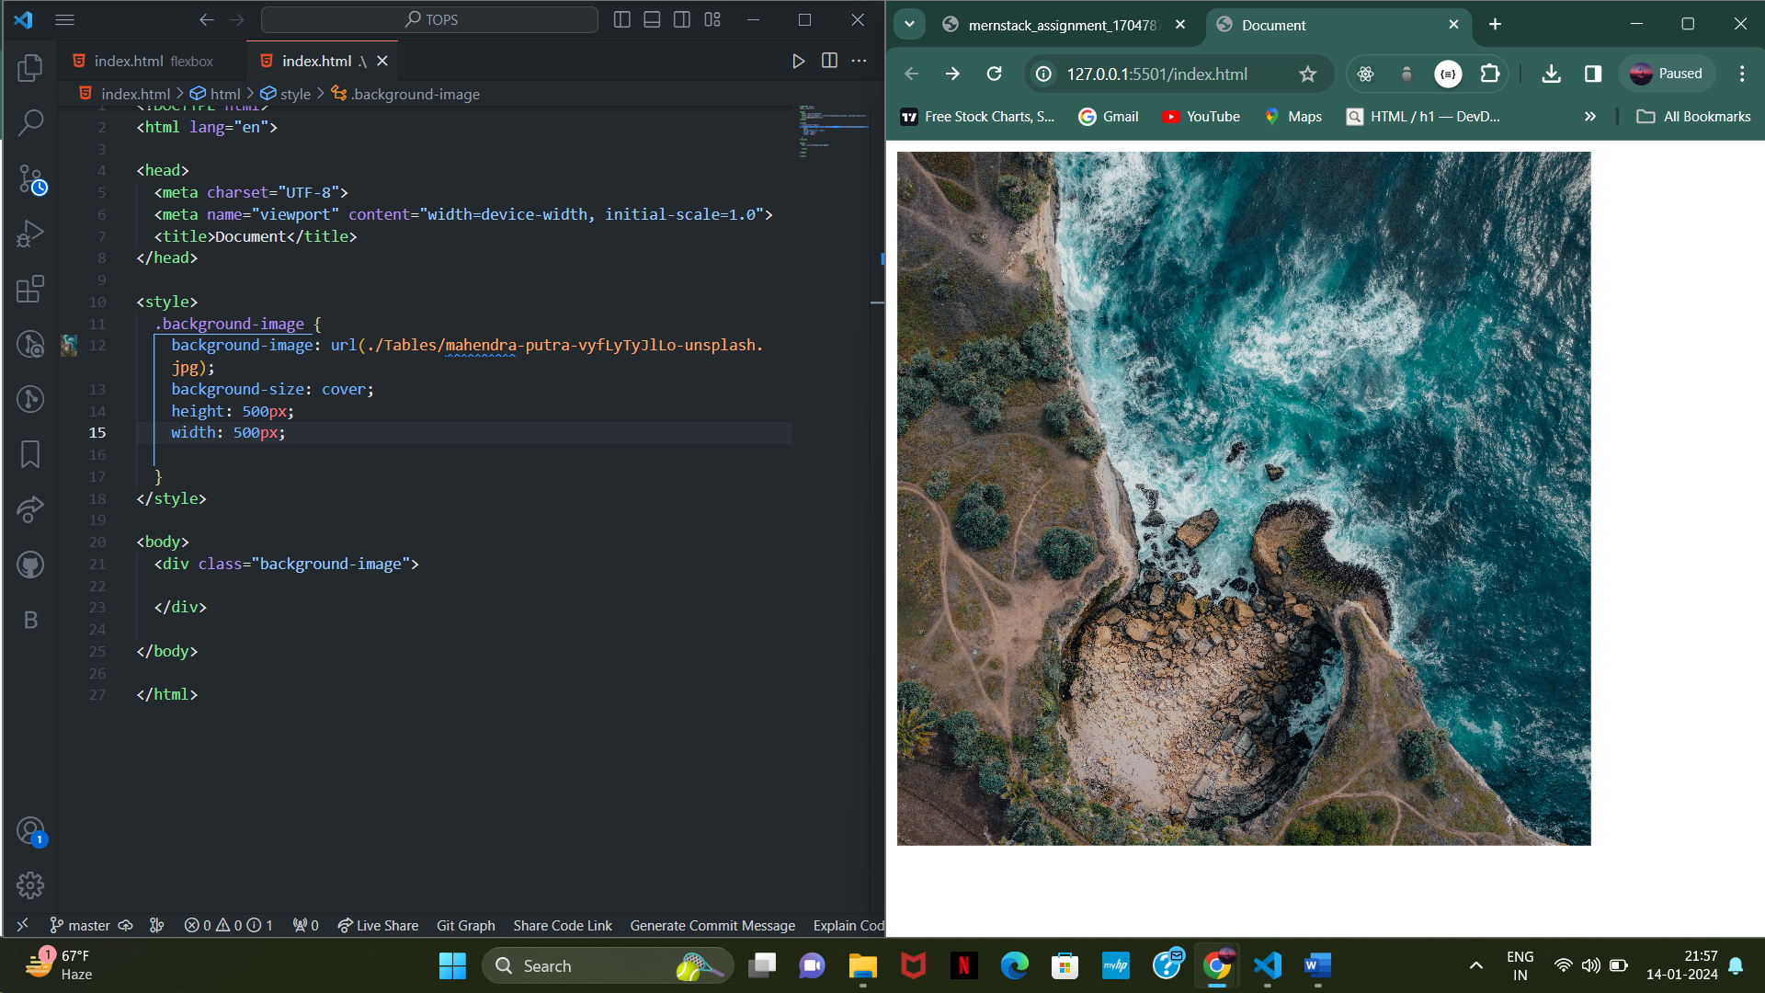

1. **How are active links different from normal links?**

* **Normal links are referred to the links which are not visited yet or not interacted by the user.**

**Colour of the normal link is blue colour**

* **Active links referred to the links which are visited or interacted by the users. Colour of the visited link is Dark Blue once user clicks the link.**

1. **What are the different tags to separate sections of text?**

* **There are many tags to separate sections of text mainly are <Div>, <P>, <h1> to </h6>, <hr>, <br>**
* **<Div> it defines as a container of content which is grouped in a division which separates content from other content**
* **<p> it defines as a paragraph and it can be used to create a Paragraph**
* **<hr> Horizontal rule is a line which separates content from different content.**

1. **What is SVG?**

* **SVG stands for scalable vector graphic which is used to create a good quality of graphics which can be scaled and resized without losing of quality of graphic.**

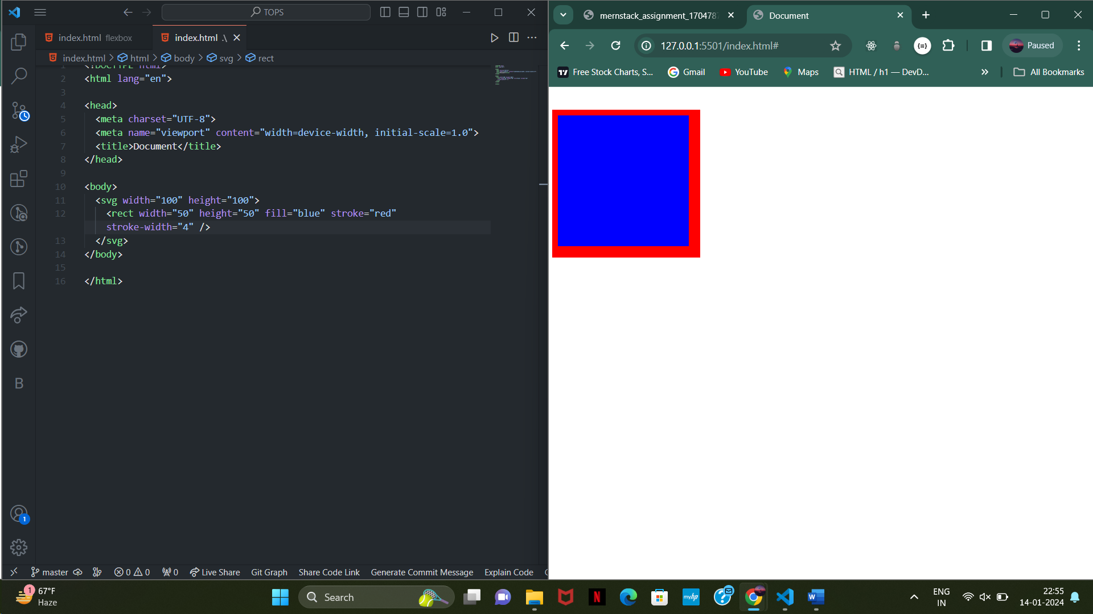

1. **What is difference between HTML and XHTML?**

* **HTML stands for (Hyper Text Markup Language) and XHTML stands for (Extensible Hyper Text Markup Language)**
* **HTML is a standard language used for creating a structure of a web page while XTML also used to create a structure of a web page but with a strict format , XML rules.**

1. **What are logical and physical tags in HTML?**

* **In HTML there are no any logical or physical tags, logical tags refer to the tags which need to be added logic in to the tag like href, src, name, value etc.**
* **Physical tags are referred to the tags which give visual appearance to the content or text.**